 **Cairo University Faculty of Computers and Information**



**Software Engineering II**

**Software design specification document**

**2020**

**Project Team**

|  |  |  |  |
| --- | --- | --- | --- |
| **ID** | **Name** | **Email** | **Mobile** |
| 20170144 | Abdelrhman hosny | [Body.hosny111@gmail.com](mailto:Body.hosny111@gmail.com) | 01018236359 |
| 20170145 | Abdelrhman reda | [Boodycat09@gmail.com](mailto:Boodycat09@gmail.com) | 01154847004 |
| 20170443 | Mohamed wael hassan | [Mohamed606tanna@gmail.com](mailto:Mohamed606tanna@gmail.com) | 01013489981 |
| 20170125 | Seif alaa eldin | [Seifalaa143@gmail.com](mailto:Seifalaa143@gmail.com) | 01156984100 |
|  |  |  |  |
|  |  |  |  |

**Mahmoed Hadad**

**Class diagram design:**

[**UML Models\Register Sequence Diagrams.jpg**](UML%20Models/Register%20Sequence%20Diagrams.jpg)

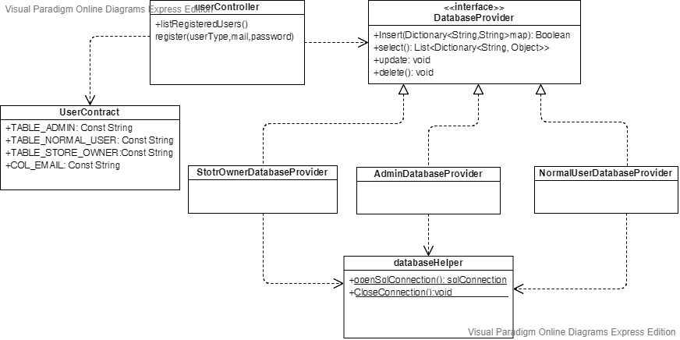

**UML Sequence Diagram Design**

**1.Registeration UML Sequence Diagram**

[**UML Models\Register Sequence Diagrams.jpg**](UML%20Models/Register%20Sequence%20Diagrams.jpg)

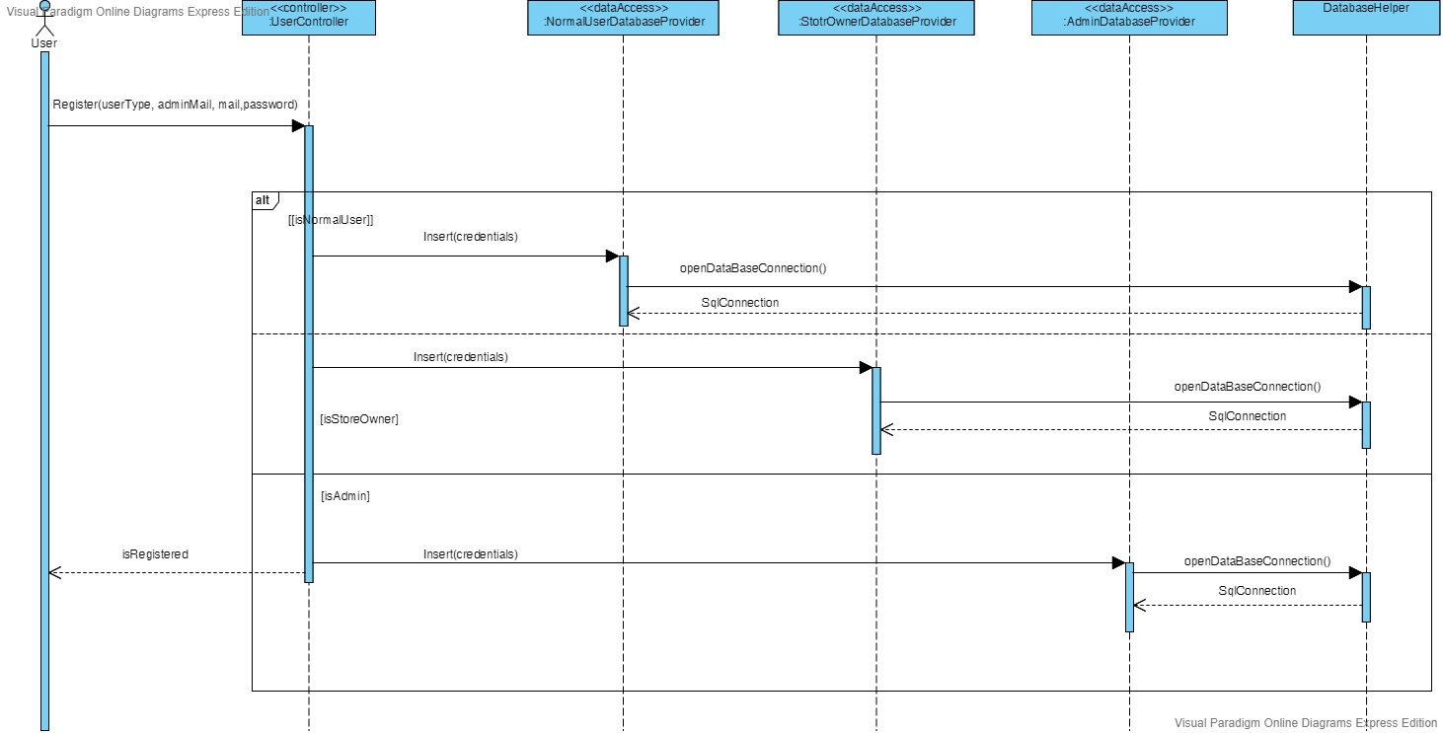

**1.List All Users UML Sequence Diagram**

[**UML Models\List All Users Sequence Diagrams.jpg**](UML%20Models/List%20All%20Users%20Sequence%20Diagrams.jpg)

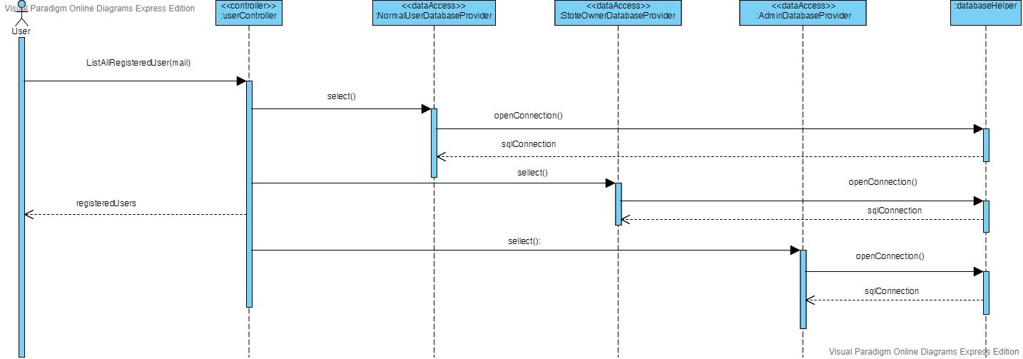

**GitHub Repository Link**

<https://github.com/AbdelrahmanReda/Software-Engineering-II-Project>

**The Repository is private so any unauthorized access will be denied.**